Dame Felicity Lott obituary: English soprano

Understated and silver-tongued English soprano who dazzled in Mozart and Strauss at Glyndebourne after initially failing an audition dies aged 79
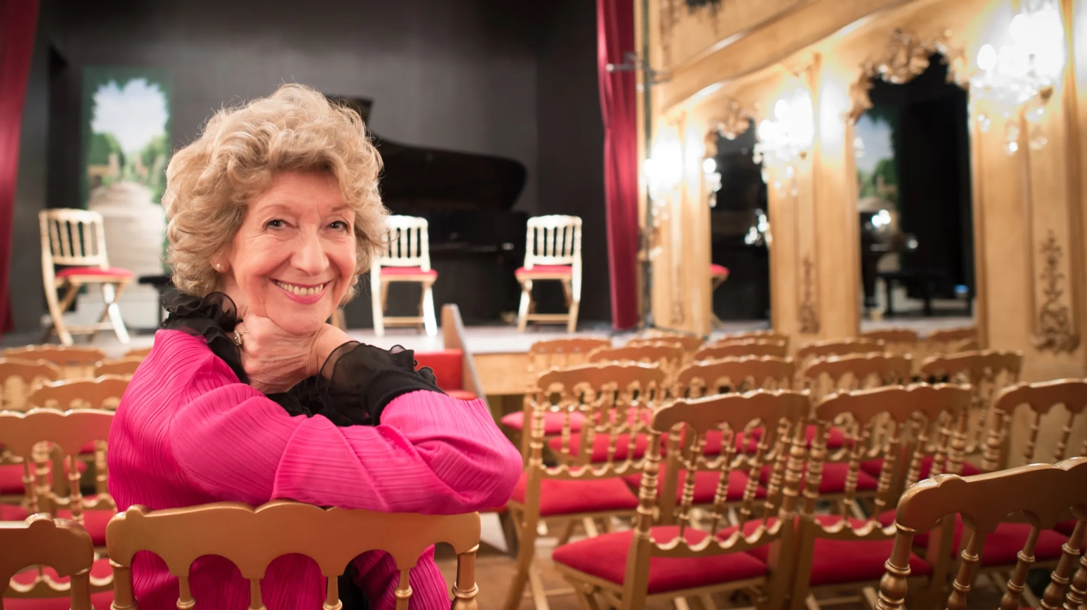Felicity Lott at Saint Bonnet Theater in Bourges, France, in 2016. She fell in love with the French language at school in CheltenhamThierry Orban/Getty Images
Felicity Lott auditioned for the Glyndebourne Opera chorus on three occasions but was turned down each time. “Then they offered me the Countess in [Strauss’s opera] Capriccio on the [1976] winter tour. I was astounded,” she told Richard Morrison in The Times. She inherited the role from Elisabeth Söderström, who had sung the part in the summer festival and who “was a wonderful model for me; a lovely singer, a fantastic actress with a very gentle and warm personality”. So too was “Flott”, as the soprano was fondly, if inevitably, known.
If Glyndebourne gave her opportunities and hay fever, she gave the Sussex opera house some of her best and most glorious years. For two decades she appeared there almost every summer, including as a gloriously confident Countess, a troubled Helena in Peter Hall’s staging of Britten’s A Midsummer Night’s Dream (1981) conducted by Bernard Haitink, and as an expressive Countess Almaviva in Mozart’s The Marriage of Figaro (also 1981). “I came here as a beginner, time slips by and suddenly I’m the singer who’s been here longer than anyone else,” she said after 11 years.
In 1986 she took a day off from being Donna Elvira in Mozart’s Don Giovanni to deliver a televised rendition of the composer’s Laudate Dominum while Andrew Mountbatten-Windsor (then Prince Andrew, Duke of York) and Sarah Ferguson signed the marriage register in Westminster Abbey. She also appeared at the Proms on two dozen occasions, including notable performances of Strauss’s Four Last Songs, though her most memorable performance was the Last Night in 1996 with Ann Murray, bringing the house down with a hilarious encore of Rossini’s Cat Duet.
Meanwhile, Lott had sung her second Strauss part for Glyndebourne in 1980, a delightful account of the teenage Octavian (a “trouser role”) in Der Rosenkavalier. The composer’s operas were becoming her calling card and in June 1990 she stormed Munich, Strauss’s birthplace, in his comic opera Intermezzo.
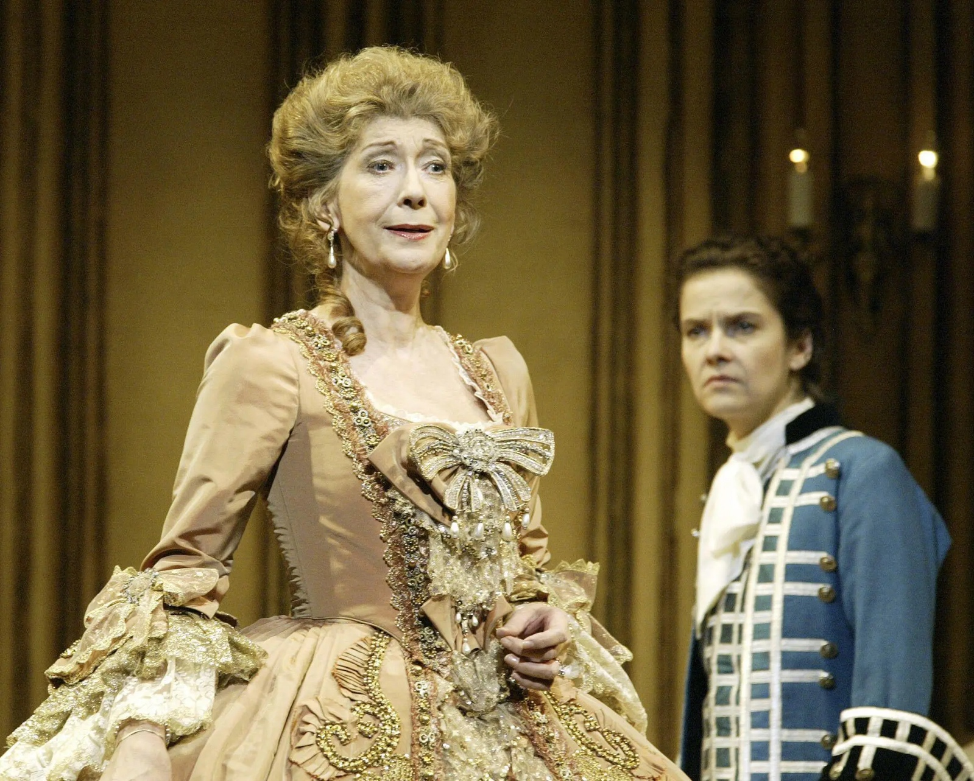In Der Rosenkavalier at the Royal Opera, 2004Alamy
That autumn, after reprising her Countess at Glyndebourne, she made her debut at the Metropolitan Opera, New York, as the Marschallin, Octavian’s discarded lover, conducted by Carlos Kleiber, for whom she became the soprano of choice. Many years later the critic Michael Kennedy, one of her greatest fans, dedicated his Strauss biography “to Dame Felicity Lott with affection and without permission”.
Willowy and serene, with an aristocratic air of calm but a down-to-earth sense of humour, Lott stood 5ft 10in, had size-seven feet and often bent her knees for tenors. “Gawky” was her own oft-repeated description of her appearance. Her silver-toned voice held up splendidly against the ravages of travel and time thanks to a careful choice of repertoire that involved avoiding 19th-century Italian opera (“Though I might be tempted by a Mimi,” she told The Times) and Wagner. “There’s no particular secret to keeping my voice in trim,” she told the French newspaper Le Monde in her typically understated manner, adding: “I’ve only sung operatic roles that suit me.”
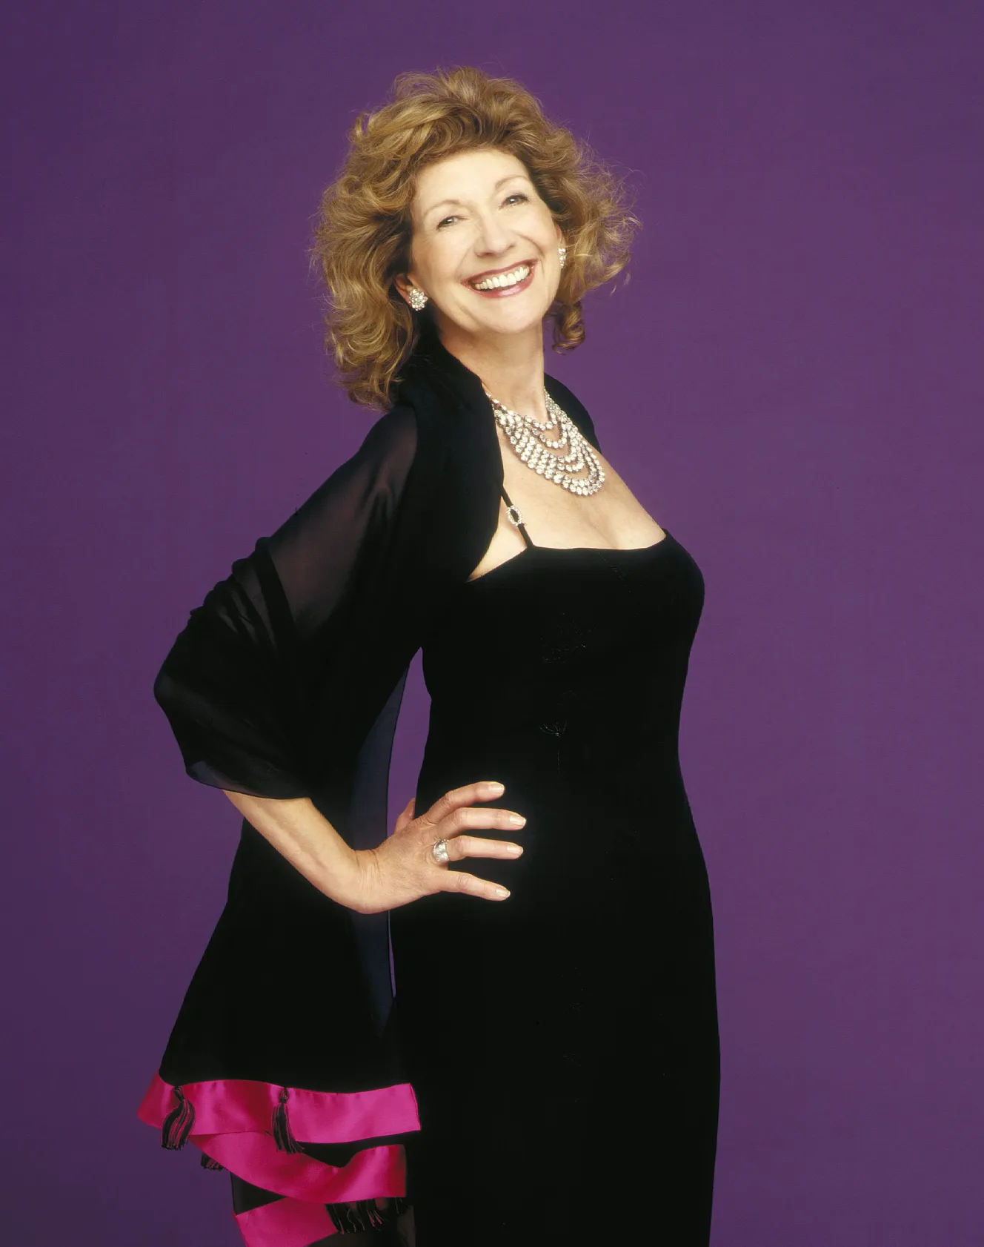TREVOR LEIGHTON
Felicity Ann Emwhyla Lott was born in Cheltenham, Gloucestershire, in 1947, the elder daughter (and “only child for eight years”) of John Lott and his wife Iris (née Williams), who ran an accountancy practice together; her sister was Deborah. At age two someone had the foresight to record her singing Away in a Manger. “It’s in tune,” she said triumphantly many years later.
Her parents’ great hobby was “amateur musicals, concert parties and pantomimes”, she told The Guardian, and she was often roped into their performances. They also “instilled a desire to work”, she told the Financial Times and from an early age she attended violin, elocution and dancing classes. She joined the Brownies, sang in the choir of Christ Church, Cheltenham, and by five was learning the piano from “a venerable, aged great-aunt who lived in a creaking large house with a parrot”. Her first singing lesson, at 12, was “from an astute lady who said I was much too young, but she would teach me to breathe”.
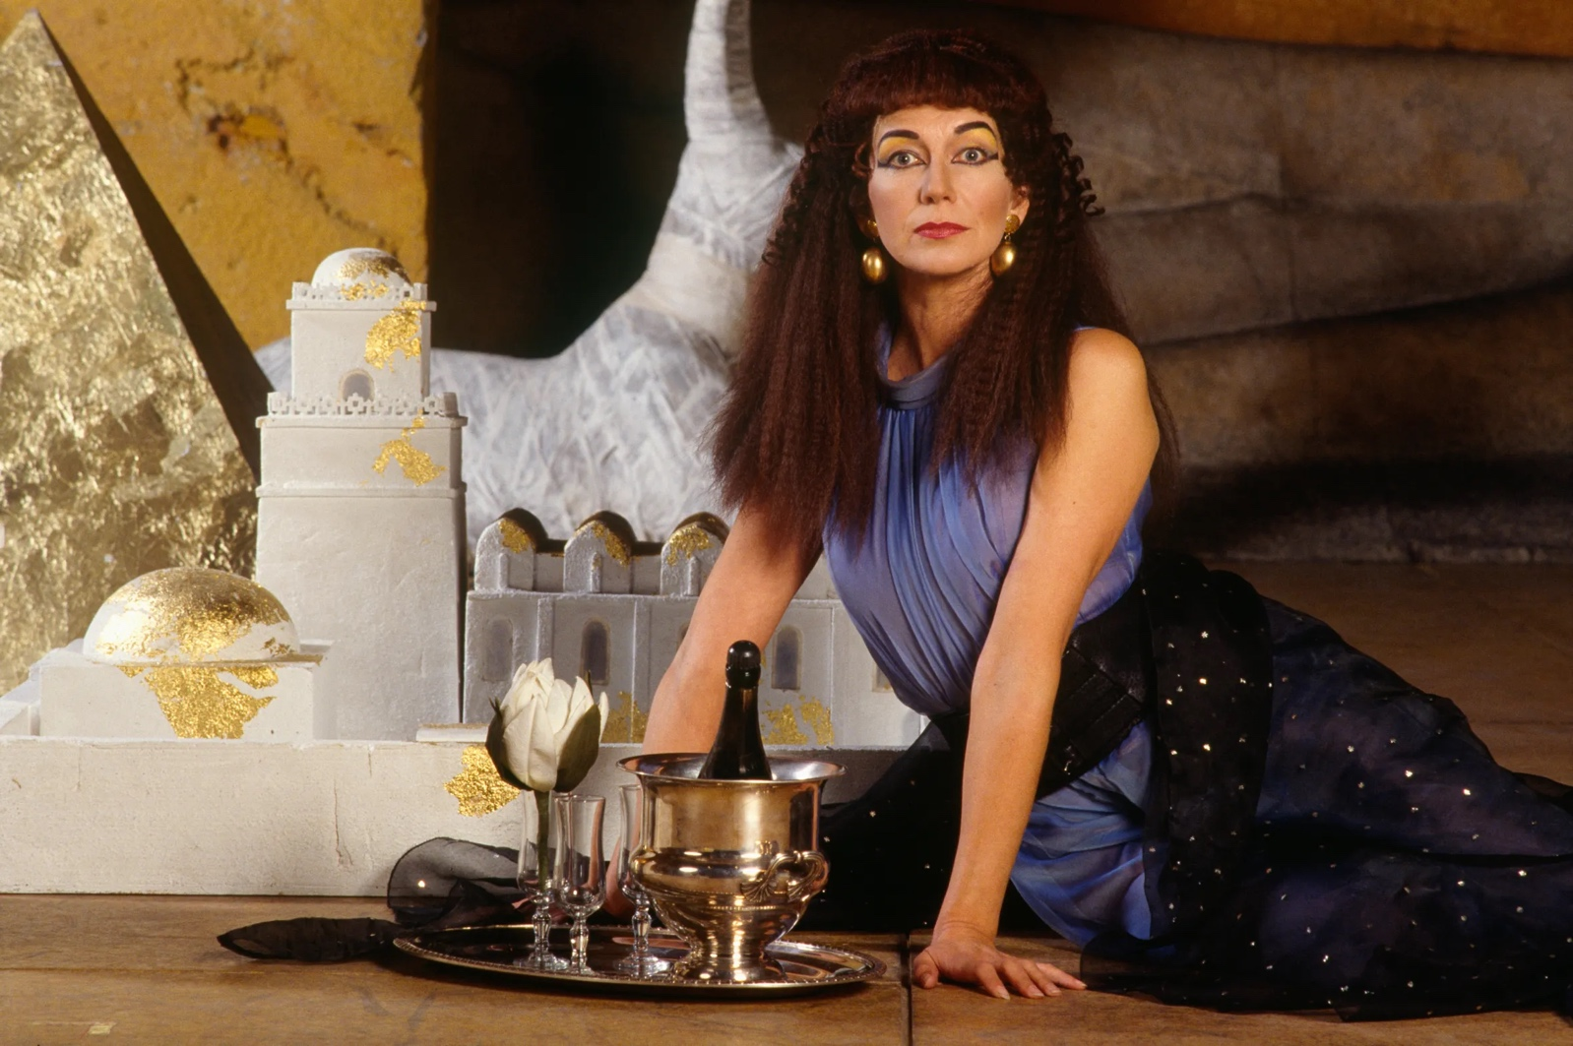Lott in Giulio Cesare by Handel at the Opera de ParisJACQUES SARRAT/Sygma via Getty Images
She sang God Be in My Head for speech days and prize days at Pate’s Grammar School for Girls, Cheltenham, where she fell in love with French. Her first taste of the stage came during her O-level year in Gilbert and Sullivan’s comic opera The Sorcerer, but that did not detract from her desire to become an interpreter and while reading French at Royal Holloway College, part of the University of London, she spent a year teaching near Grenoble.
As an antidote to the classroom she took singing lessons at the local conservatory, where an inspirational teacher suggested that she might make “something” of her voice. “I had always sung but I never thought of it seriously as a job. Then I began to despair of what I could actually do,” she told The Times, explaining on another occasion that by then she was realising her interpretation skills were not quick enough. “You can’t afford to drag your heels at the Geneva conference,” she said.
After a summer music school in Nice, “where I learnt a lot more French and met professional singers for the first time”, she returned to Britain to become a mature student at the Royal Academy of Music in London, later picking up the principal’s prize. “I think they gave it to me because I was the oldest student there,” she joked. Embroiled in the heady atmosphere of college opera productions, she attracted positive reviews from the critics. “A quite outstanding talent,” noted Alan Blyth in The Times in 1972. “A bright, full voice, an innate stylist and attractive stage personality,” added Stanley Sadie in the paper a year later.
She sang with the BBC Singers, made the rounds of the country’s choral societies (“a wonderful way for a young singer to get experience”) and performed with the pianist Graham Johnson, her fellow student, and his Songmakers’ Almanac. Their first programme was on the theme of vice. “Songs about smoking and drinking,” she explained. “People did not realise they were allowed to laugh.” Among her many recordings with Johnson was a light-hearted disc for a French company, Felicity Lott S’Amuse (“Felicity Lott has Fun”).
At the Royal Academy she had met Robin Golding, a musicologist, and they were married in 1973. The marriage was dissolved and in 1984 she married Gabriel Woolf, the actor and broadcaster, who was 15 years her senior. They had met in 1980 when she sang soprano to his narration of Honegger’s King David in Liverpool. It was pretty much love at first sight, she explained, which “caused a few problems here and there”. They lived close to the Sussex coast and had a daughter, Emily, who as a child often accompanied her mother on tour.
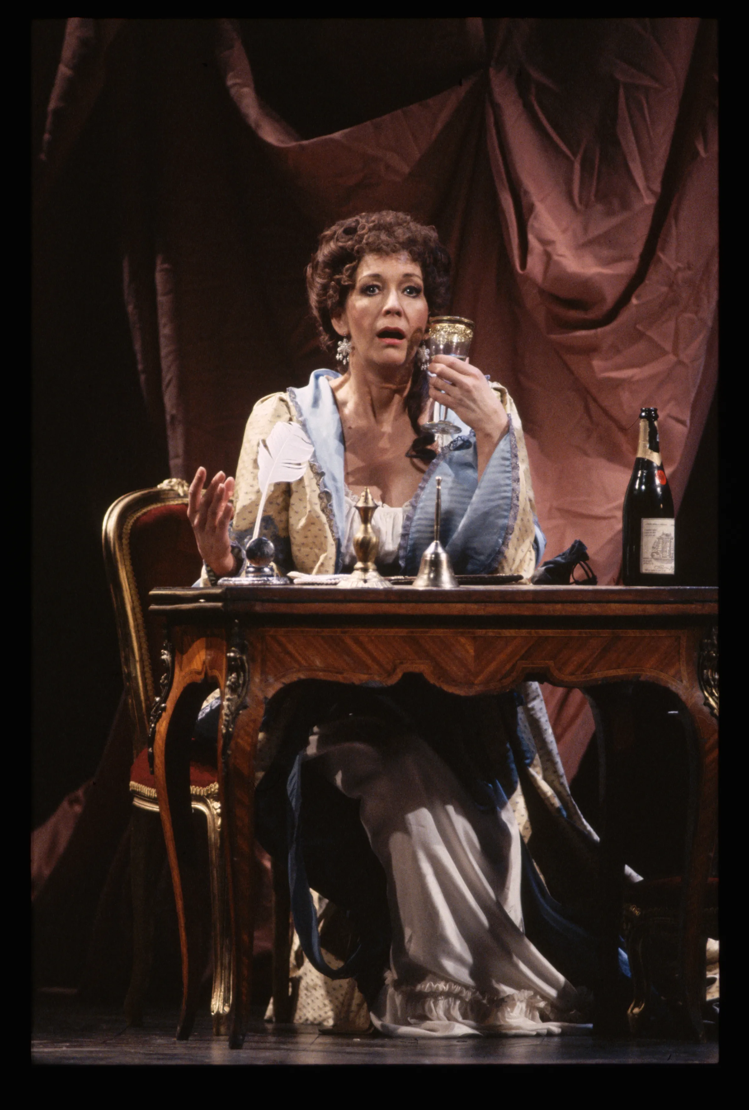The Marriage of Fiagaro at the Royal Opera House, December 1991robbie jack/Corbis/Getty Images
Meanwhile, Lott had been enjoying a series of memorable debuts, starting in Abingdon in 1973 as a clear-voiced Seleuce in Handel’s Tolomeo for Unicorn Opera in Abingdon. Two years later she stepped up at a day’s notice while understudying for Pamina in Mozart’s The Magic Flute for English National Opera on tour in Bristol. “It’s a wonderful way to start. You haven’t time to be nervous,” she told Opera magazine. She was later an impressive Fiordiligi in Mozart’s Così fan tutte and an impassioned Natasha in Prokofiev’s War and Peace for the company.
For a time she seemed sidetracked by 20th-century opera: two small roles in Hans Werner Henze’s We Come to the River for her debut at the Royal Opera House, Covent Garden in 1976, a triumphant Jennifer in Tippett’s A Midsummer Marriage for Welsh National Opera in 1977 and a demure Anne in Stravinsky’s The Rake’s Progress at Glyndebourne. Nevertheless, she returned to Strauss’s grand ladies while continuing to sing Mozart, including Donna Elvira in Don Giovanni, a part she always found upsetting because “nobody wants her”.
She also excelled in French opera, giving a deeply moving account of Poulenc’s monodrama La Voix Humaine for Glyndebourne’s 1977 tour. As Sister Blanche in the composer’s Dialogues des Carmélites with Régine Crespin at Covent Garden in 1983 she struggled to hold back the tears at the opera’s sad ending. “I cry easily,” she confessed to one interviewer while weeping during lunch at the mention of a heart-rending song. Her later opera appearances included the ghastly Lady Billows in a revival of Peter Hall’s staging of Albert Herring at Glyndebourne in 2002 and, fittingly, a reprisal of her dignified Marschallin with Angelika Kirchschlager’s playful Octavian for Covent Garden in 2004.
By then she had discovered operetta, immersing herself in various Merry Widows and Grand Duchesses of Gerolstein. Laurent Pelly’s staging of Offenbach’s La Belle Hélène at the Paris Châtelet in 2001 was, she told the Sunday Telegraph, life-changing. “It was so liberating, after all my ‘ladies’, to do something different — and athletic, leaping all over the stage,” she said, though eventually she sprained her ankle. Bringing the role to the Coliseum in 2006 proved a treat. “I love the role,” she told The Times. “Nothing is ever Hélène’s fault. A dishy young man turns up in her bed — so clearly she must have dreamt it. Terrific excuse. All of life should be like that.”
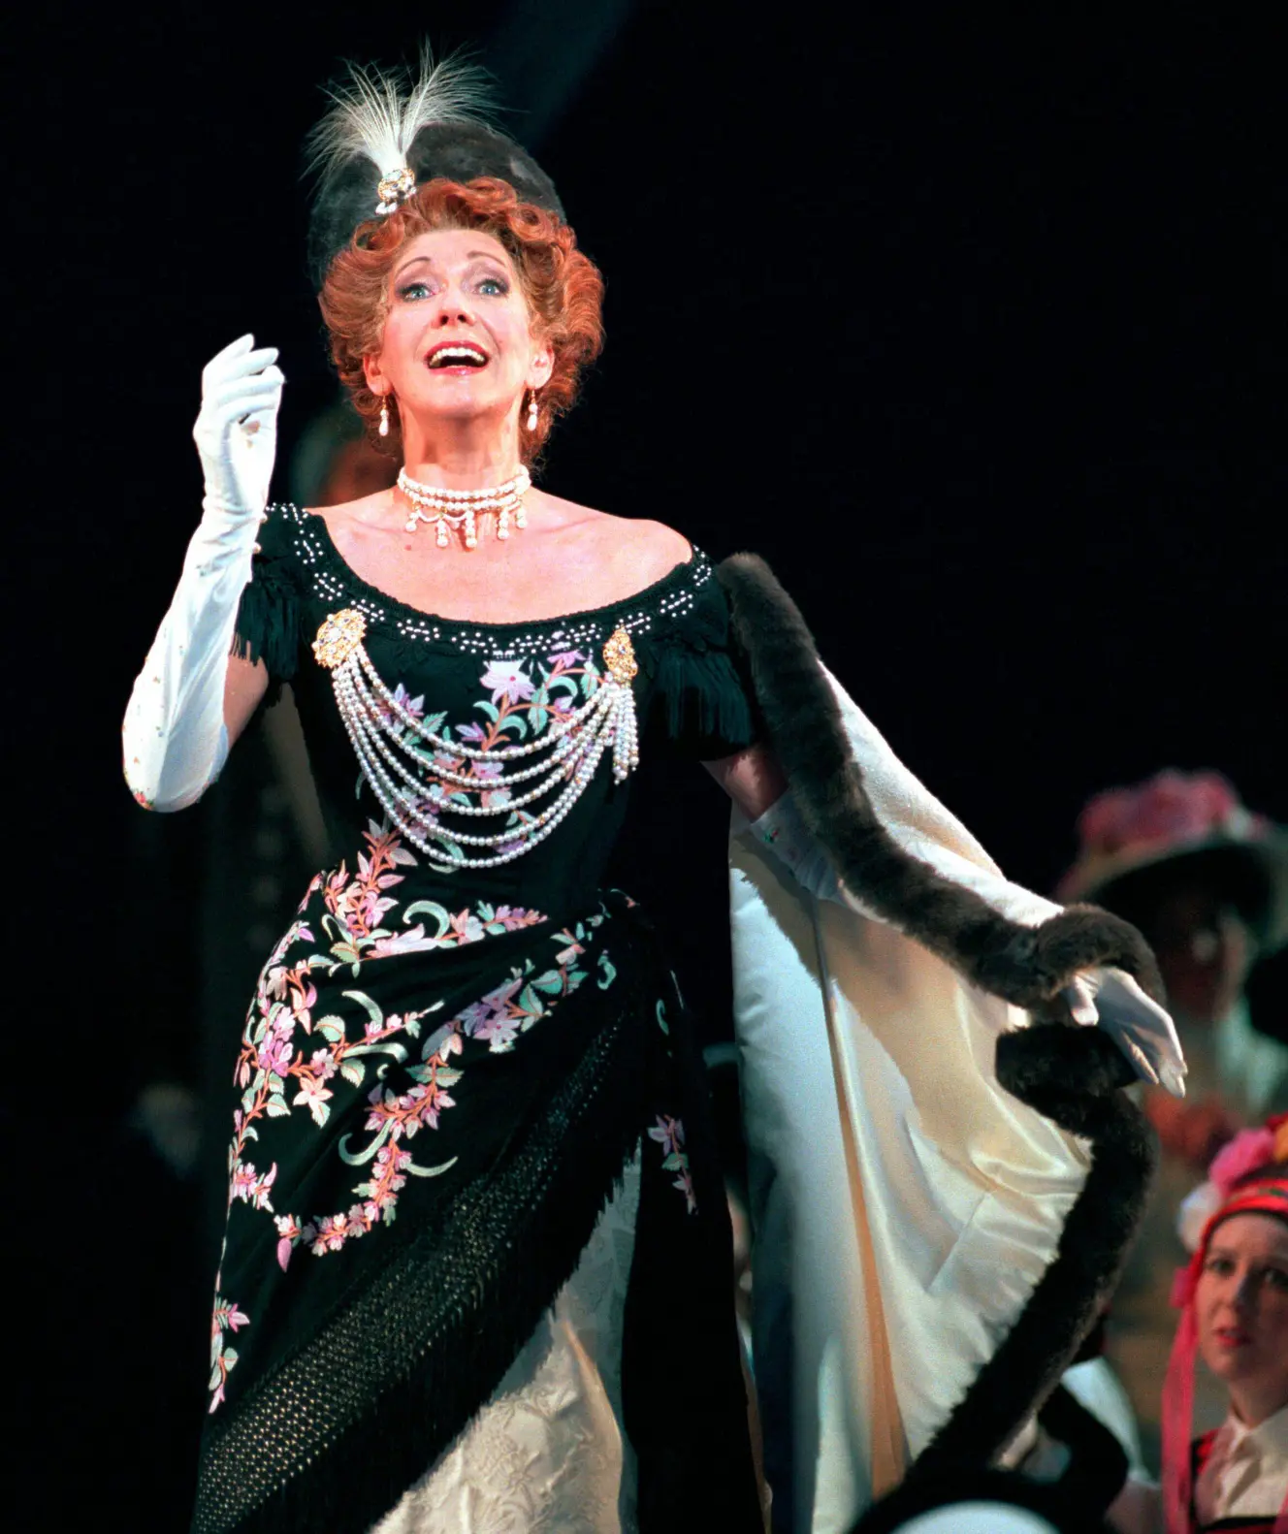In The Merry Widow at Shaftesbury Theatre, 1997Alamy
Appearing on Desert Island Discs in 2008, Lott said: “I just hope that somebody is going to tell me that I ought to stop before everybody says, ‘What a shame she didn’t stop’.”
Five years later, she took matters into her own long-fingered and expressive hands in a farewell recital at her beloved Wigmore Hall with Graham Johnson, who so often accompanied her there. They signed off with Bernstein’s valedictory number Take Care of This House.
Dame Felicity Lott, soprano, was born on May 8, 1947. She died of lung cancer on May 15, aged 79

